Monday | Tuesday | Wednesday | Thursday | Friday
English:  Complete Worksheet Adjectives 1  Gaeilge:  Éide Scoile Nua: Léigh agus freagair na ceisteanna (Read and answer the questions) Sheet 1  Try Duolingo each day for ten minutes or watch some cartoons/scoil on TG4  https://www.duolingo.com/course/ga/en/Learn-Irish  Mental Maths tables:  All classes  Tables x 5 and 10 revision  Daily Ten: https://www.topmarks.co.uk/maths-games/daily10  Ms Kenna’s class:  Number of the day = 212  Money Revision = 15 – 20 minutes written work a day.  Work through MM pages 145, 146 and 147 this week.  *Remember to use RUDE when problem solving. READ the question. UNDERLINE the keywords. DECIDE what method you will use (multiplying or adding if you need to get a bigger number, dividing or subtracting if you need to get a smaller number. Also remember sometimes problems will have more than 1 step, you may have to do 2 or 3 steps). ESTIMATE your answer.  Extension work: MM p 144  Mrs Harte & Ms Murtagh’s class:  Complete 1 Brain Teasers activity every day  Brain Teasers 9&10  Continue with topic of Weight  Remember 1000g = 1 kilogram  15 minutes of written work every day  MM pg 124 q 1&3  Mr Donohoe & Ms Lynn’s class:  Time  Money  SESE - History:  Ask somebody who is older than you to describe the types and styles of clothes that they wore when they were your age.  - If possible, see if they have any photographs of when they were younger.  - Compare and contrast the clothes you wear today to the materials/ styles/ colours that were worn in the past.  Discuss how fashion has changed throughout History. | English:  Fashion Show: Use as many adjectives as you can to describe what you and the other people in your house are wearing. E.g.: I am wearing a light, short-sleeved, pink t-shirt.  Try to write 8 sentences altogether.  Gaeilge:  Sheet 2  Féach ag an bpictiúr agus scríobh na focail ceart.  Look at the picture and write the correct words for each item of clothing.  Try Duolingo each day for ten minutes or watch some cartoons/ scoil on TG4  https://www.duolingo.com/course/ga/en/Learn-Irish  Mental Maths Tables:  All classes  Tables x5 and x10  Hit the button:  https://www.topmarks.co.uk/maths-games/hit-the-button  Ms Kenna’s class:  Number of the day = 2020  Money Revision = 15 – 20 minutes written work a day.  Work through MM pages 145, 146 and 147 this week.  Extension work: MM p 144  Mrs Harte & Ms Murtagh’s class:  See Monday Brain Teasers 10  MM pg 124 q 2 &4  Mr Donohoe & Ms Lynn’s class:  Money 2  SESE Geography: Use the Internet to research traditional clothes from around the World.  Think about why these clothes may have been chosen- e.g.: climate.  Some examples of countries to research- Japan, Spain, Scotland, India, Vietnam, etc. | English:  Write a short paragraph (1 copy page) using descriptive text on one of the following scenarios:  - A storm in a rainforest.  - An encounter with a wild animal.  or  - A scenario of your choice.  Gaeilge:  Fill in the blanks on Sheet 3.  Try Duolingo each day for ten minutes or watch some cartoons/ scoil on TG4  https://www.duolingo.com/course/ga/en/Learn-Irish  Mental Maths Tables:  All classes  Tables x 5 and 10 revision  Daily Ten: https://www.topmarks.co.uk/maths-games/daily10  Ms Kenna’s class:  Number of the day = 5103  Money Revision = 15 - 20 minutes written work a day.  Work through MM pages 145, 146 and 147 this week.  Extension work: MM p 144  Mrs Harte & Ms Murtagh’s class:  Brain Teaser 11&12  Problem Solving- Remember the RUDE method- Read, Underline, Draw/ Decide, Estimate before working out.  MMpg 125 q1&2  Mr Donohoe & Ms Lynn’s class:  Addition and Subtraction  SPHE  Choose one activity from the Kindness Calendar to do every day. | English:  Read the Procedure page and answer the questions. (you do not have to actually make the jewellery to complete this exercise.  If you do have the materials and equipment available, try to follow the instructions to make your own jewellery.  Gaeilge:  Scríobh abairtí in ord.  Write sentences in order.  Abair Liom D  Mental Maths:  All Classes  Tables x 5 and 10 revision  Ms Kenna’s class:  Number of the day = 89  Money Revision = 15 – 20 minutes written work a day.  Work through MM pages 145, 146 and 147 this week.  Extension work: MM p 144  Mrs Harte & Ms Murtagh’s class:  Brain Teasers 12 (see Wed)  Problem Solving pg 125 q 3&4  Mr Donohoe & Ms Lynn’s class:  Division 5s  (Count in 5s, use your Number Worm for help if needed)  SESE Science  Watch this short video about materials:  https://www.youtube.com/watch?v=88i-IVkMR3U  - Write down the key words that are on the top right of the screen as it goes along .  - At the end of the video, see if you can remember what the words mean. Re-watch if you need to.  - List which types of materials are best for  - Shelter  - Sleeping  - Fishing  - Cooking | English:  Just like last week try to listen to one of David Walliams ELEVENSES on his website https://www.worldofdavidwalliams.com/  Or spend 20 minutes reading yourself!  Gaeilge:  Fill in the blanks- remember ró + h.  Abair Liom E  Try Duolingo each day for ten minutes or watch some cartoons on TG4  https://www.duolingo.com/course/ga/en/Learn-Irish  Maths:  All classes  Tables x 5 and 10 revision  See if someone can test you on your 5 and10 times tables! Good luck!  Ms Kenna’s class:  Number of the day = 1415  Money Revision = Online games for at least 20 minutes.  1. Work out how much change is needed in this game - https://www.topmarks.co.uk/money/toy-shop-money/eur  2. Scroll down to the money section here and choose some skills to revise - https://ie.ixl.com/math/class-4  3. See how well you know the value of coins in this game - https://www.teachingmoney.co.uk/eurosite/games/coinxEURO.html  Mrs Harte & Ms Murtagh’s class:  Complete the Giant Pizza Competition Page  Mr Donohoe & Ms Lynn’s class  Multiplication 6s  (Try without your Number Worm first and then use it to check your answers)  Art:  Design an outfit.  Choose one of the following suggestions to design an outfit/ costume  - Dance costume  - Football/ basketball kit  - New school uniform  Think about what kind of materials you would choose and why.

Physical Exercise: 60 minutes make sure to get active every day – go for a walk, cycle your bike, practice your GAA or Soccer drills,
Go Noodle, Cosmic kids, Yoga, Kids Pilates
We also encourage our children to take part in The Body Coach Joe Wicks daily P.E session on Youtube at 9am
DEAR Time: Spend 15 minutes reading a book every day.
Extra activity: If you get a chance please watch RTE2 daily school at eleven o’clock each morning also!
TG4 also have lessons as Gaeilge at ten o’clock each morning.
Stay well and safe – we are thinking of you all and miss you all!

Ms Lynn’s English Groups
Please keep all your work in your copy and folder
To open links press ctri and click
Monday | Tuesday | Wednesday | Thursday | Friday
Look at the list of  st/ -str words below  Read them aloud  burst  story  strong  Strip  stream  distance  least  street  Pick 5 words and write them into sentences. | https://www.k12reader.com/worksheet/community-connections/view/  Scroll down to community connections  Read the story and answer the questions.  Check your answers with the answer sheet provided | https://www.youtube.com/watch?v=1Iv-Ttr_Xm8&t=141s  Read along with the narrator:  The Stranger by Norman Whitney Chapter 2  Answer the following questions  - When did the last shop close in Woodend?  - What was the name of the village school teacher?  - The shop will sell “Village Products”. What are these?  - WHAT was Dave Slatin’s plan for the shop?  - On what date did the shop open? | https://www.youtube.com/watch?v=eBQx5nD68Ug  Watch the video on using effective verbs/instructional verbs in procedural writing. | Make a list of effective/ instructural verbs or bossy verbs as they are called.  How many can you list?  Can you draw your favourite dessert?

Ms. Cawley - English:
Hello everyone, I hope you are well. It’s great to have the good weather and I hope that everyone is still remembering to follow all the rules about social distancing and coughing into our elbows. I know it is a very strange, difficult time but we will all get through it and be back together. Below is this weeks’ work. Try and do your best but don’t feel under any pressure to complete it all. Save all your work so we can correct it when we are back together.
Monday:
How did you get on with last week’s tongue twister? I found it tricky at the start of the week but definitely got quicker as the week went on. Here is another one for this week. Practice it slowly and then see how quick you can get. Maybe you could challenge someone in your house to see who can say it the best or the quickest?
http://learnenglishkids.britishcouncil.org/tongue-twisters/big-black-bug
This weeks’ story: https://www.storynory.com/the-first-strawberries/
As you’re listening to the story, follow the words of the story that are written on the website.
After listening to the story, answer the following:
- What kind of world do the man and woman live in?
- How does the man feel when the woman leaves him?
- What part does the sun play in this story?
- What does the woman feel when she tastes the strawberries?
Tuesday:
Listen to the story again.

Vocabulary and Grammar

1) "They lived as happily _____ any man and woman have ever lived together, until they began to quarrel."
What is the missing word?
a) like
b) with
c) as
d) to

2) "She walked and walked, always ____ straight ahead of her, and not once turning back."
What is the missing word?
a) looked
b) look
c) looks
d) looking
3) "It saw that there was sadness on the face of an otherwise pristine and perfect world."
What is another word for "pristine" ?
a)Shining
b) untarnished
c) wonderful
d) beautiful

4) "And the sun took pity ___ the first man, and decided to help him."
What is the missing word?
a) to
b) at
c) on
d) with

Practice the tongue twister again, have you noticed that you’re getting better?

Wednesday:
Tongue twister time! Who do you think is best at saying it in your house?
Make a list of everything in your bedroom then play the game below and see how many of these bedroom items are in your home. You could test yourself and try to spell them.
https://www.eslgamesplus.com/bedroom-esl-vocabulary-memory-game/

Thursday:
Try these crosswords: http://iteslj.org/cw/3/ck-dolch05.html and http://iteslj.org/cw/3/ck-dolch06.html . Click on the numbers to see the clues. Complete the crossword puzzle, then click on "Check Puzzle."
Friday:
This game is all about prepositions, you can set up teams in your home if you like! https://www.eslgamesplus.com/preposition-interactive-grammar-game-for-esl-wheel-game/

Keep going with the tongue twister, if you had access to a mobile phone you could record yourself saying it.

Try and read as much as you can, you can ask an adult to set up an audible account to listen to some stories. https://stories.audible.com/start-listen
Stay safe!
Sheet 1 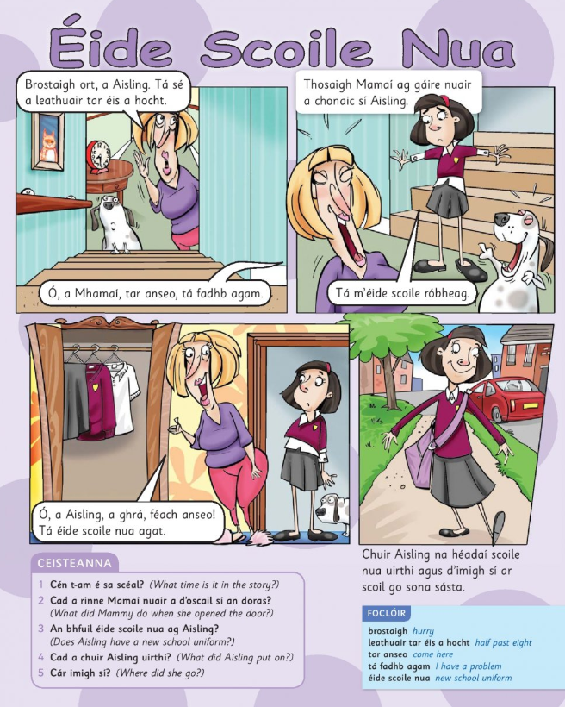

Sheet 2
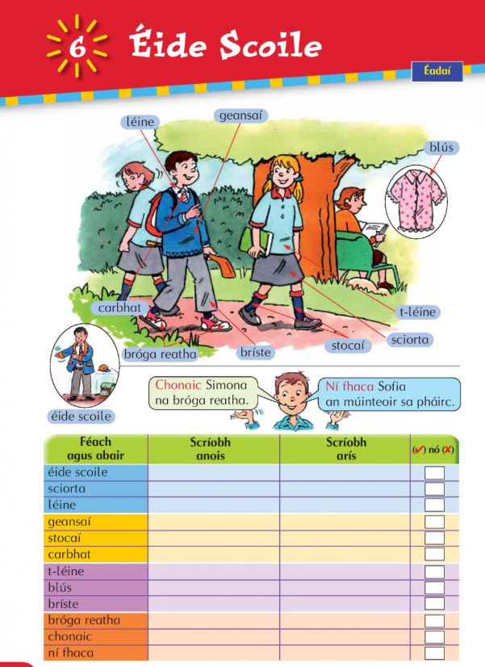

Sheet 3
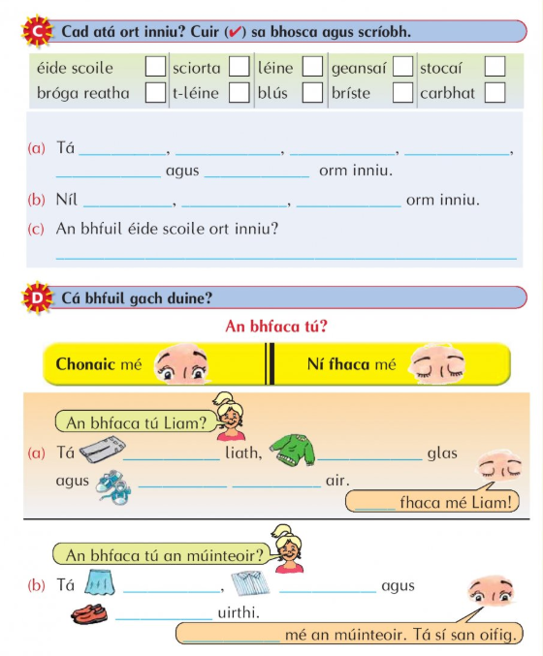

Abair Liom D
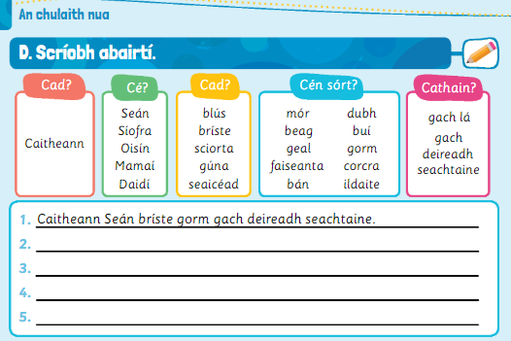

Abair Liom E
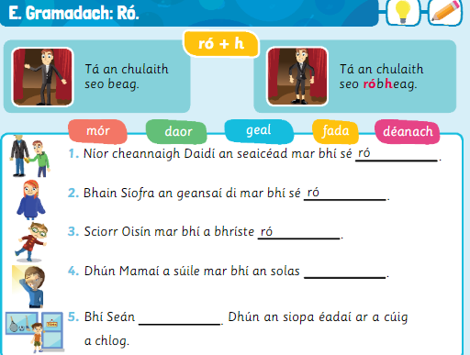

Procedure
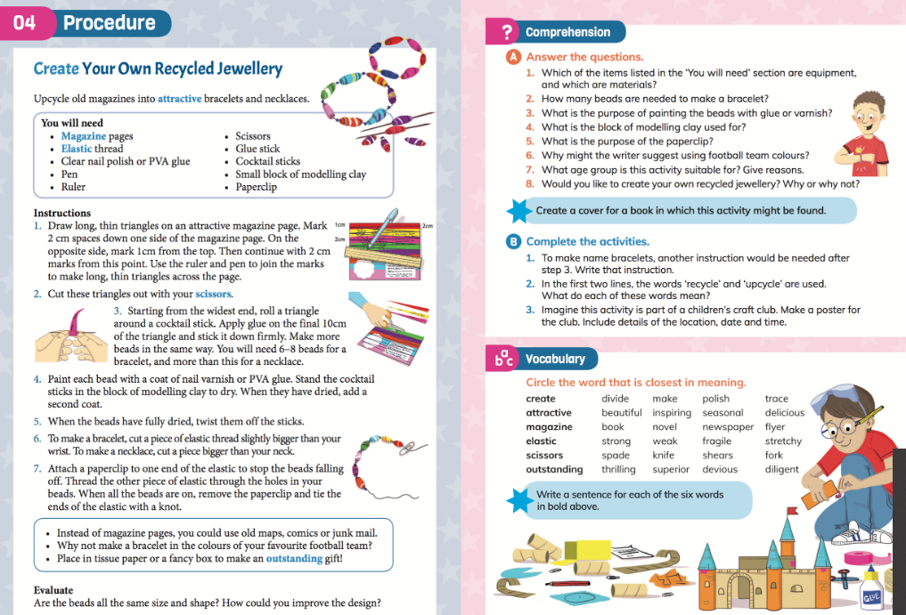

Brain Teasers 9&10
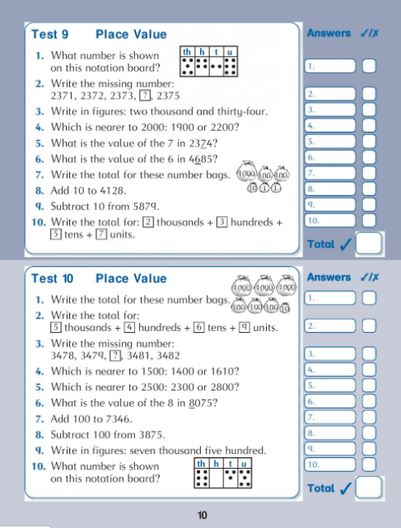

Brain Teaser 11&12
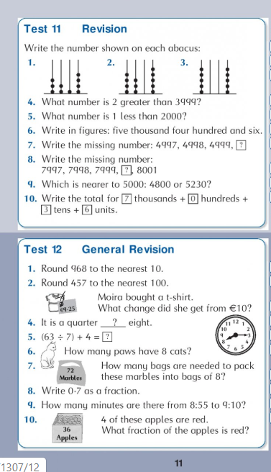

Giant Pizza Competition Page
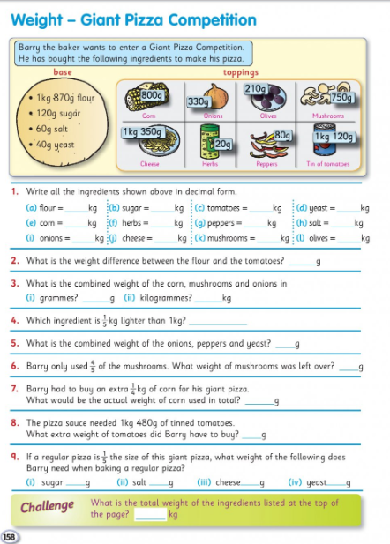

Adjectives 1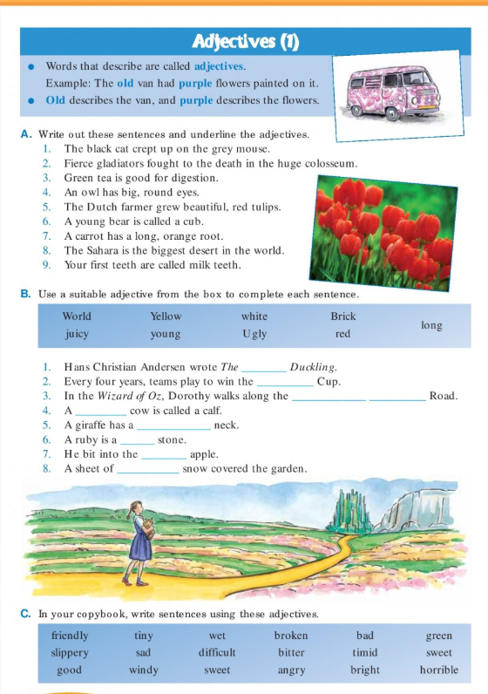

Kindness Calendar

