Zoom Gloom

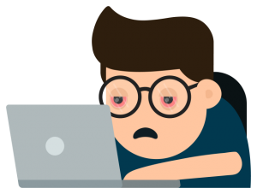
Distance learning. What a bore.
Our school's been closed a month or more.
I'm stuck at home. I'm in my room,
and meeting with my class on Zoom.
There's no more lunchroom. No PE.
Just studying and tests for me.
There's no more recess. No more ball.
Just staring at my bedroom wall.
The playground's closed—the swings, the slide—
and everybody's stuck inside.
We can't go out and play with friends.
I hope that, pretty soon, this ends.
I know it's only for a while,
but here's a thought that makes me smile:
Although it might not sound so cool,
I just can't wait to go to school.

By Kenn Nesbitt

