Work for fourth class St Philips 11th-15th May 2020

Monday | Tuesday | Wednesday | Thursday | Friday
English:  Write down one happy thought for today.  Write a letter to your favourite sports star/ musician. Tell them about yourself, tell them why you admire them and ask them three questions. (See letter template below)  Gaeilge:  Try Duolingo each day for ten minutes.  Watch Cúla4 ar scoil @10am https://www.cula4.com/en/shows/cula4-ar-scoil/  https://www.duolingo.com/course/ga/en/Learn-Irish  Maths:  Mental maths all classes:  Write out your doubles eg 2+2, 3+3, 4+4, 5+5, 6+6, 7+7, 8+8, 9+9, 10+10, 11+11, 12+12  You must learn these by heart.  https://www.topmarks.co.uk/maths-games/daily10  https://www.topmarks.co.uk/maths-games/hit-the-button  Mrs Harte/ Ms Murtaghs maths class:  Brainteasers test 17 (resources section)  Mathemagic  Reminder:  1000ml = 1 litre  Continue with capacity pg 160 questions 5-7  Ms Kennas maths class  Number of the day = 391  Data Revision = 20 minutes written work a day.  Work through MM pages 18, 21, 22 and 23 this week.  *Remember data is information in the form of a graph or a chart. When you interpret the data (the chart) you are looking at it to find out information (answer questions about what you can see).  Extension work: MM p 19 and 20  Mr Donohue/ Ms Lynns maths class:  1)Mental Maths(Skip 11 and 12)  2)Rounding  3) Addition and Subtraction  SESE:  Have a look at these fun science experiments – maybe you could do some at home (always have an adult present if you are trying these)  https://www.youtube.com/watch?v=4MHn9Q5NtdY | English:  Write down one happy thought.  Phone a friend or a family member and ask them the questions below.  (Questions attached below timetable)  Gaeilge:  Oral Language questions on  GAEILGE NEAMHFHOIRMIÚIL  (see sheet below). Try and work on questions 1-5 today  Maths:  Mental maths all classes:  Practice your doubles  https://www.topmarks.co.uk/maths-games/daily10  Daily Ten: Practice rounding  Hit the button: Practice Halves and Doubles  https://www.topmarks.co.uk/maths-games/hit-the-button  Mrs Harte/ Ms Murtaghs maths class:  Brainteasers test 18 ( resources section)  Mathemagic pg 161  questions 1-5  Ms Kennas maths class  Number of the day = 402  Data Revision = 20 minutes written work a day.  Work through MM pages 18, 21, 22 and 23 this week.  Extension work: MM p 19 and 20  Mr Donohue/ Ms Lynns maths class:  - Mental Maths  (Skip 10 and 15)  - Skip Counting  - Fractions  SESE  Read about the European Union using the link below. Rewrite fact number 10 in your own words.  List the countries in the EU  https://www.kids-world-travel-guide.com/eu-facts.html | English:  Write down your happy thought.  Revision work : write down 10 pairs of antonyms (opposites) and 10 synonyms(words that mean the same)  Eg.antonyms: new and old  black and white  Synonyms : nice and good  talk and speak  15 minutes handwriting book  Gaeilge:  Read the following story and answer the questions – try your best!  https://www.cogg.ie/wp-content/uploads/3.An-Samhradh-asal.pdf  Maths:  Mental maths all classes:  Tables write out x6 x9  Daily Ten: Practice Ordering  https://www.topmarks.co.uk/maths-games/daily10  Mrs Harte/ Ms Murtaghs maths class:  Brainteasers test 19 (resources section)  Mathemagic pg 173 questions 8 and 9  Ms Kennas maths class  Number of the day = 1234  Data Revision = 20 minutes written work a day.  Work through MM pages 18, 21, 22 and 23 this week.  Extension work: MM p 19 and 20  Mr Donohue/Ms Lynns maths class:  - Mental Maths  (Skip 13 and 15)  - Time  3)Rounding Game  SESE:  Complete a project on The European Union max 2 pages long.  (May include: What it is, why it was formed, when it was formed, the six founding countries, when Ireland joined, Brexit ) | English:  Write down your happy thought.  Dear 2030 me…  Write a letter to 2030 you. What would you like to remember from this time? What do you hope to have achieved by 2030? After you have finished the letter you can give it to a family member to keep safe and give it to you in 2030.  (Use the letter template below)  Gaeilge:  Oral Language questions on  GAEILGE NEAMHFHOIRMIÚIL  (see sheet below) Please work on questions 5-10 today  Maths:  Mental maths all classes:  Tables write out x6 x9  Daily Ten: Practice fractions  Hit the button: Practice number bonds  https://www.topmarks.co.uk/maths-games/daily10  https://www.topmarks.co.uk/maths-games/hit-the-button  Mrs Harte/ Ms Murtaghs maths class:  Brainteasers test 20 (resources section  Giving ml and litres in fraction and decimal form ( worksheet in resources section)  Ms Kennas maths class  Number of the day = 4321  Data Revision = 20 minutes written work a day.  Work through MM pages 18, 21, 22 and 23 this week.  Extension work: MM p 19 and 20  Mr Donohue/ Ms Lynns maths class:  - Mental Maths  (Skip 13, 14, 15, 16)  - Multiplication  - Symmetry Game  SESE:  Continue a project on The European Union 2 pages long.  (May include: What it is, why it was formed, when it was formed, the six founding countries, when Ireland joined, Brexit) | English:  Write down your happy thought.  Think about five acts of kindness you will do over the weekend and write them down.  Gaeilge:  Try Duolingo each day for ten minutes  Watch Cúla4 ar scoil @10am  https://www.cula4.com/en/shows/cula4-ar-scoil/  Maths:  Mental maths all classes:  Tables : ask an adult to test you on your x6 and x9 tables and your doubles  Daily Ten: Practice digit values  Hit the button: Practice number bonds with decimals  https://www.topmarks.co.uk/maths-games/daily10  https://www.topmarks.co.uk/maths-games/hit-the-button  Mrs Harte/ Ms Murtaghs maths class:  Brainteasers test 21 (resources section)  Multiplication and division revision sheet ( resources section)  Ms Kennas maths class:  Number of the day = 524  Data Revision = Continue with this week’s written work.  Have a go at this bar chart game. Start with level 1 and then see if you can move on to levels 2 and 3. https://mathsframe.co.uk/en/resources/resource/51/bar_charts  Mr Donohue/ Ms Lynns maths class:  1)Mental Maths  (Skip 5,8,10,14)  2)Division  3) Measuring Game  Art/ SPHE  Practice this drawing meditation if you are feeling worried or anxious or just want to relax https://www.youtube.com/watch?v=Eyrj1P26yNg
Physical Exercise: 60 minutes make sure to get active every day – go for a walk, cycle your bike, practice your GAA or Soccer drills,
Go Noodle, Cosmic kids, Yoga, Kids Pilates
We also encourage our children to take part in The Body Coach Joe Wicks daily P.E session on Youtube at 9am
GAA have some ideas and tutorials https://learning.gaa.ie/
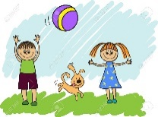
DEAR Time: Spend 15 minutes reading your book.
Extra activity: If you get a chance please watch RTE2 daily school at eleven o’clock each morning also!
If you do not have the books ask your classmate to send you a picture. Choose to do literacy or numeracy work using those sites.
Stay well and safe – we are thinking of you all and miss you all!

Ms. Cawley - English:
Hello everyone, I hope you are all well. As you all know school won’t be back before the summer. I know this is a very strange time for us all. Keep trying to get a little bit of work done and read as much as you can. Stay safe
Monday:
Here is another tongue twister for this week. Practice it slowly and then see how quick you can get. Maybe you could challenge someone in your house to see who can say it the best or the quickest?
http://learnenglishkids.britishcouncil.org/tongue-twisters/cup-coffee

Comprehension – Eiffel Tower. Click on the pdf and read the comprehension and answer the questions. Follow question 10 to learn how to draw the Eiffel Tower
Tuesday:
Tongue twister time! Who do you think is best at saying it in your house?
Revise opposites by play this game.
https://www.eslgamesplus.com/practice-adjectives-opposites-esl-connector-matching-game/
Which word has the closest meaning to the underlined word? You could use a dictionary to help you if you find this a bit tricky.
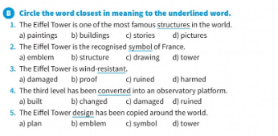
Wednesday:
Keep going with the tongue twister, if you had access to a mobile phone you could record yourself saying it.
Try these crosswords: http://iteslj.org/cw/3/ck-dolch09.html and http://iteslj.org/cw/3/ck-dolch10.html click on the numbers to see the clues. Complete the crossword puzzle, then click on "Check Puzzle."

Thursday:
I thought today you could try something different! Watch the following video on how to make a bowling game. You might need a couple of days to collect all the materials but I think it would be great fun! You could challenge a family member!
http://learnenglishkids.britishcouncil.org/how-videos/how-make-bowling-game
Friday:
This game revises actions and nouns. Click on the dice and answer the questions to reach home.
https://www.eslgamesplus.com/action-verbs-noun-collocations-esl-vocabulary-grammar-interactive-crocodile-board-game

Ms Lynn’s English Groups Monday 11th- Friday 15th May
Please keep all your work in your copy
Monday | Tuesday | Wednesday | Thursday | Friday
Days, Weeks and months  ( Remember to use capital letters)  1.Write out the names of the days of the week.  2.Write out the names of the months of the year.  3.In what month is your birthday?  4.In what month is Christmas Day?  5.Which month has the fewest number of days?  6. What are the months of Summer? | Similar sounding words  Choose the correct words from the brackets to complete the sentences below  - I am going to ---------- a present for mum  ( by,buy )  2.Sally wore her -------- shoes.  ( new , Knew )  3.The ------- looked very calm.  (see, sea )  4.We lost -------- way in the fog.  ( our, hour)  5. Tim was -------- after his illness.  ( week, weak )  6. The ------- has long ears and a short tail.  (hare, hair)  7.The cyclist ----- quickly along the narrow ----.  (rode, road) | Make your own list of 3 letter ar words e.g bar  Now can you write a list of 4 letter ar words  e.g. cart  dark  Try and write as many as you can | Verbs are action words.  e.g. Tim walked home.  Can you think of other verbs.  Make a list of all the verbs you can think of. | Choose the correct verb to complete the sentences.  Was / were  - All the boys ------- playing football.  - None of the animals------- harmed by the fire.  - They ---- making model planes.  - Every girl------ in the swimming pool.  Is / are  1.Anybody----- allowed to borrow a book.  2.Not one of the children –  absent from school.  3.Everyone of the bottles –  broken.  4.All the children ---- visiting the museum.

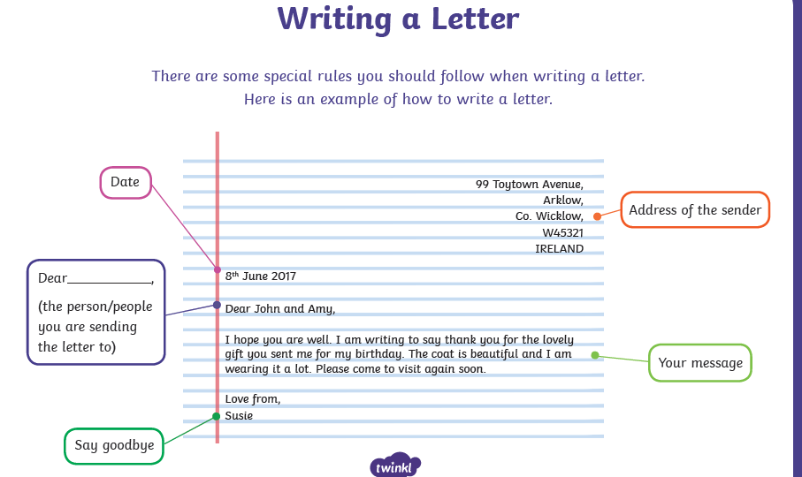
GAEILGE NEAMHFHOIRMIÚIL
1 | Dia duit  Hello
2 | Conas atá tú?  How are you? | Tá mé go maith  Tá mé go hiontach  Tá mé ar fheabhas  Níl mé go maith | Tá tuirse an domhain orm  Tá tart orm  Tá mé go h-uafásach  Tá mé tinn  Tá ocras orm
3 | Cén sórt lae atá ann?  What sort of day is it? | Lá breá brothallach atá ann  Lá gaofar atá ann  Lá stoirmiúil atá ann  Lá scamallach atá ann  Lá grianmhar atá ann
4 | Conas atá an aimsir inniu?/ Cén sort aimsire atá ann?  How is the weather today? | Tá an ghrian ag taitneamh  Tá scamaill sa spéir  Tá sé ag cur báistí  Tá sé ag stealladh báistí  Tá an ghrian ag taitneamh ach tá sé fuar  Tá scamaill sa spéir ach tá sé te.
5 | Cén aois tú? What age are you?
6 | Cá bhfuil tú i do chonaí? Where do you live?
7 | Cé mhéad duine atá i do chlann? How many people are in your family?
8 | Cé mhéad deirfiúr/deartháir atá agat? How many sisters/brothers do you have?
9 | Cé mhéad seomra atá i do theach? Ainmnigh iad. How many rooms are in your house? Name them.
10 | Cén scoil ina bhfuil tú? What school are you in?

Phone a friend/ Family member
What is your favourite food?
My Guess:
Real Answer:
What is your favourite hobby?
My Guess:
Real Answer:
What is your favourite animal?
My Guess:
Real Answer:
Would you rather be as tall as a house or as small as a mouse?
My Guess:
Real Answer:
What have you been doing to keep busy?
My Guess:
Real Answer:
Who is your biggest role model? Why?
My Guess:
Real Answer:
Who inspires you the most? Why?
My Guess:
Real Answer:

What is your favourite country you’ve visited?
My Guess:
Real Answer:
What is your favourite memory of me?
My Guess:
Real Answer
What are you missing the most?
My Guess:
Real Answer:
Where is the last place you visited?
My Guess:
Real Answer:
Do you have a question for me?
My Guess:
Real Answer:

