Monday | Tuesday | Wednesday | Thursday | Friday
English:  Read the comprehension, ‘Space Race’. Answer the questions into your copy.  Gaeilge:  Watch Cúla4 ar scoil at 10am on TG4  https://www.cula4.com/en/shows/cula4-ar-scoil/  Try Duolingo each day for ten minutes  https://www.duolingo.com/course/ga/en/Learn-Irish  Mental Maths tables:  All classes  Tables ÷2 learn and test yourself.  Daily Ten: https://www.topmarks.co.uk/maths-games/daily10  Ms Kenna’s class:  Number of the day = 823  Weight Revision  If you have a weighing scales at home that you can use, try MM page 121 Q 1 and Q 2. If you don’t have all the things that are mentioned weigh some other things that you do have!  Try these games: https://www.ictgames.com/mobilePage/mostlyPostie/index.html , https://www.transum.org/Maths/Activity/Reading_Scales/Default.asp?Level=2 , http://flash.topmarks.co.uk/4769  *Remember 1000g = 1 kg  Mrs Harte & Ms Murtagh’s class:  Brain Teaser27  Continue with Length from last week. Use a ruler to measure the perimeters on page 77 of Mathemagic.  Mr Donohoe & Ms Lynn’s class:  Addition  Rounding  Egg Project: (Science and Art)  This can be done on Seesaw or upload a photo onto Seesaw to show your results.  Task: Design a ‘space shuttle’ that would keep an astronaut safe as it descends back to Earth after a mission in space.  - Use a boiled egg as the ‘astronaut’. Very important- ask for help from a grown up to make this.  - Use household items to construct the space shuttle.  - Drop the egg in the space shuttle from a height of about 5 feet.  - Take a photo of the egg and space shuttle and report if you think that this was protective enough- did it crack? What you could do to improve it.  - Be creative and have fun! This can be done at any stage during the week. | English:  Would you like to be an astronaut?  - Write a story, ‘If I were an astronaut…’  Or  - Write a diary entry for a day in the life of an astronaut.  (Should be about a copy page in length).  Gaeilge:  Léigh an scéal faoi Cú Chulainn  Look up the highlighted words using an online dictionary.  Try Duolingo each day for ten minutes or watch some cartoons on TG4  https://www.duolingo.com/course/ga/en/Learn-Irish  Mental Maths Tables:  All classes  Tables x12 revision  Hit the button:  https://www.topmarks.co.uk/maths-games/hit-the-button  Ms Kenna’s class:  Number of the day = 687  Weight Revision = 20 minutes written work a day.  Work through MM pages 120, 121 (Q 4 and Q 5),122 and 123 this week.  Extension work: Online games from Monday  Mrs Harte & Ms Murtagh’s class:  Brain Teaser 28  Page 111 Mathemagic Questions 1, 2, 3- Addition and subtraction.  Mr Donohoe & Ms Lynn’s class:  Subtraction  Time  SESE:  Read about Neil Armstrong following this link:  https://www.natgeokids.com/au/discover/science/space/neil-armstrong-facts/  Pick the top 5 facts about Neil Armstrong to compile a short biography. | English:  Speech Marks activity. Write out what each person says, putting speech marks in the correct places.  Gaeilge:  Freagair na ceisteanna don scéal Cú Chulainn. Read the story from yesterday and answer the questions into your copy.  Try Duolingo each day for ten minutes or watch some cartoons on TG4  https://www.duolingo.com/course/ga/en/Learn-Irish  Mental Maths Tables:  All classes  Tables x12 revision  Daily Ten: https://www.topmarks.co.uk/maths-games/daily10  Ms Kenna’s class:  Number of the day = 5678  Weight Revision = 20 minutes written work a day.  Work through MM pages 120, 121 (Q 4 and Q 5),122 and 123 this week.  Extension work: Online games from Monday  Mrs Harte & Ms Murtagh’s class:  Brain Teaser 29  Mathemagic page 111 Questions 4,5,6- Multiplication and Division of metres and centimetres.  Mr Donohoe & Ms Lynn’s class:  Multiplication  Money  SESE - History:  Watch this video about the moon landings:  https://www.youtube.com/watch?v=CbTaDOuSePk  See if you can answer these questions:  - What year did the first Moon Landing take place?  - Name the three astronauts on board.  - Which astronaut didn’t step foot on the Moon?  - What was the name of the space shuttle?  - How many people watched the Moon landings around the World?  Have you any relatives who can recall watching the Moon landings? Ask them what they can remember from this time. | English:  Read the poem, ‘Planet Roll Call’ and try to learn the order of the planets.  A mnemonic is a helpful way to learn the order of the planets, e.g.:  My Very Educated Mother Just Served Us Noodles.  Can you create your own mnemonic to help you learn the order of the planets? Share this on Seesaw.  Gaeilge:  Practise reading the story of Cú Chulainn aloud.  Try Duolingo each day for ten minutes or watch some cartoons on TG4  https://www.duolingo.com/course/ga/en/Learn-Irish  Mental Maths Tables:  All classes  Tables x12 revision  Hit the button:  https://www.topmarks.co.uk/maths-games/hit-the-button  Ms Kenna’s class:  Number of the day = 226  Weight Revision = 20 minutes written work a day.  Work through MM pages 120, 121 (Q 4 and Q 5),122 and 123 this week.  Extension work: Online games from Monday  Mrs Harte & Ms Murtagh’s class:  Brain Teaser 30  Mathemagic page 112  Problems q 1-5  Mr Donohoe & Ms Lynn’s class  Division  Multiplication  SESE – Label the planets in order on the page below and learn the poem, ‘Planet Roll Call’.  Mini-project: Use the internet to research one planet. Write out 5 facts about this planet | English:  Just like you’ve done before, try to listen to one of David Walliams ELEVENSES on his website https://www.worldofdavidwalliams.com/  Or spend 20 minutes reading yourself!  Gaeilge:  Complete the aí worskeet. Use your dictionary if you are unsure of the words and spelling.  Watch Cúla4 ar scoil at 10am on TG4  https://www.cula4.com/en/shows/cula4-ar-scoil/  Try Duolingo each day for ten minutes  https://www.duolingo.com/course/ga/en/Learn-Irish  Maths:  All classes  Tables x12  See if someone can test you on your 12 times tables! Good luck!  Ms Kenna’s class:  Number of the day = 174  Weight Revision = 20 minutes written work a day.  Work through MM pages 120, 121 (Q 4 and Q 5),122 and 123 this week.  Extension work: Online games from Monday  Mrs Harte & Ms Murtagh’s class:  Ask somebody older to test you on your ÷2 tables (they write up the bigger number, you divide by two and write your answer as quickly as possible).  Mathemagic page 112  Problems q 6-10  Mr Donohoe & Ms Lynn’s class  Addition and Subtraction Word Problems  RUDE Strategy  R: Read the problem  U: Underline the key parts  D: Decide whether it is addition or subtraction  E: Evaluate (Check over your answer)  Art:  Don’t forget to upload your space shuttle constructions onto Seesaw, we are really looking forward to seeing your ideas.
Physical Exercise: 60 minutes make sure to get active every day – go for a walk, cycle your bike, practice your GAA or Soccer drills.
Go Noodle, Cosmic kids, Yoga, Kids Pilates
We also encourage our children to take part in The Body Coach Joe Wicks P.E daily session on Youtube at 9am.
The GAA have some ideas and tutorials here https://learning.gaa.ie
DEAR Time: Spend 15 minutes reading your book.
If you get a chance, please watch the Home School Hub at 11:00 am each morning on RTE2!
If you do not have the books, ask your classmate to send you a picture or try to find the books online (MM or Mathemagic 4 is available for free on the CJ Fallon website). There is no pressure to get all activities completed so just try your best!
Stay well and safe – we are thinking of you all and miss you all!

Ms Lynn’s English Groups Monday 25th – Friday 29th May Learning at Home Week 7
Please keep all your work in your copy and folder
To open links press ctrl and click
Monday | Tuesday | Wednesday | Thursday | Friday
https://www.youtube.com/watch?v=BZf60cb3Th8  Listen to the story Stone Soup.  Listen for any rhyming words . | Listen to the story again and answer the following questions.  1.What were the travellers looking for?  2.What did the travellers decide to do?  3. How did they make their soup?  4.Can you name some of the ingredients that people brought?  5. What was the magic ingredient ?  6. What was the message at the end of the story? | Name as many vegetables as you can. How many did you get?  Divide your page into 12 boxes. Draw a vegetable in each box and write the name underneath . | https://starspell.app/currentExercise/2022  Click this link. Here are “i-e” words  Read the list. Try  Learn  Spell  Starpick  Starguess  Pick five of these words and write them into sentences | Can you make your own cartoon of the story?  Divide your page into 6 boxes. Draw your story and don’t forget to use your speech bubbles.  I would love to see your work on seesaw

Ms. Cawley - English:
Hello everyone, I hope you are all well. Keep up the great work! Stay safe
Monday:
Here is another tongue twister for this week. Practice it slowly and then see how quick you can get. Maybe you could challenge someone in your house to see who can say it the best or the quickest? The good weather last week made me want some ice cream!
http://learnenglishkids.britishcouncil.org/tongue-twisters/i-scream-you-scream
Comprehension – http://learnenglishkids.britishcouncil.org/reading-practice/superheroes
Click on the link above. It will bring you to a worksheet on superheroes. Work at your own pace through the tasks on the worksheet.
Tuesday:
Keep going with the tongue twister, if you had access to a mobile phone you could record yourself saying it.
Try these crosswords: http://iteslj.org/cw/3/ck-dolch13.html and http://iteslj.org/cw/3/ck-dolch14.html click on the numbers to see the clues. Complete the crossword puzzle, then click on "Check Puzzle."
Wednesday:
http://learnenglishkids.britishcouncil.org/worksheets/free-time-activities
Click on the link and complete the worksheet on free time activities. When you work out the mystery word you could post it to your seesaw account!
Thursday:
Write 5 sentences on “Who is you favourite superhero and why?” Remember not all superheroes wear capes! You could post this to your seesaw account.
Have a final go at this week’s tongue twister.
Friday:
Revise comparing adjectives.
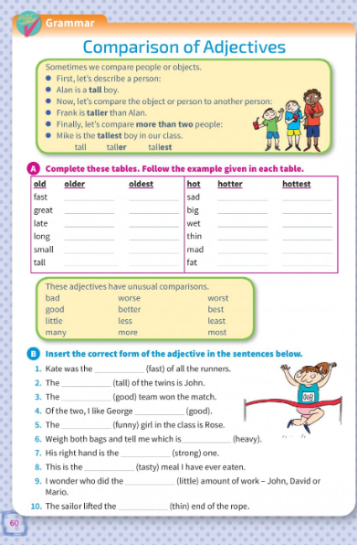

Space Race Comprehension
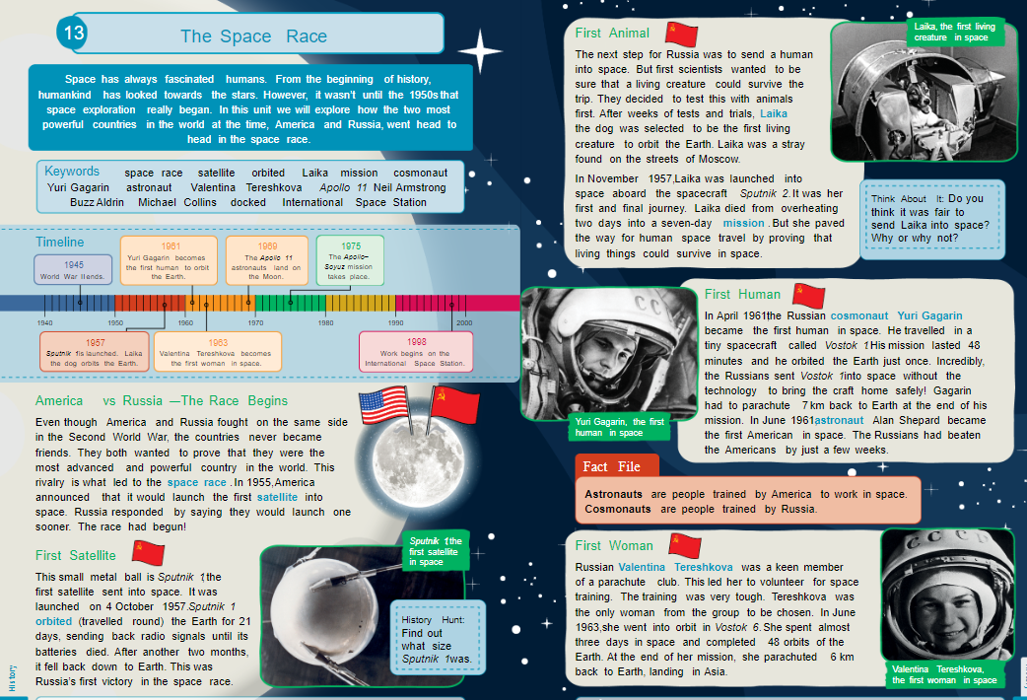
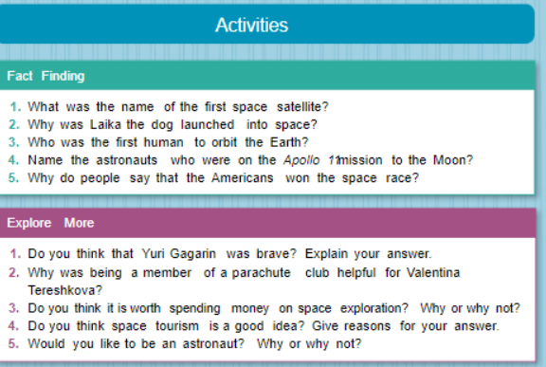

Speech Marks Activity

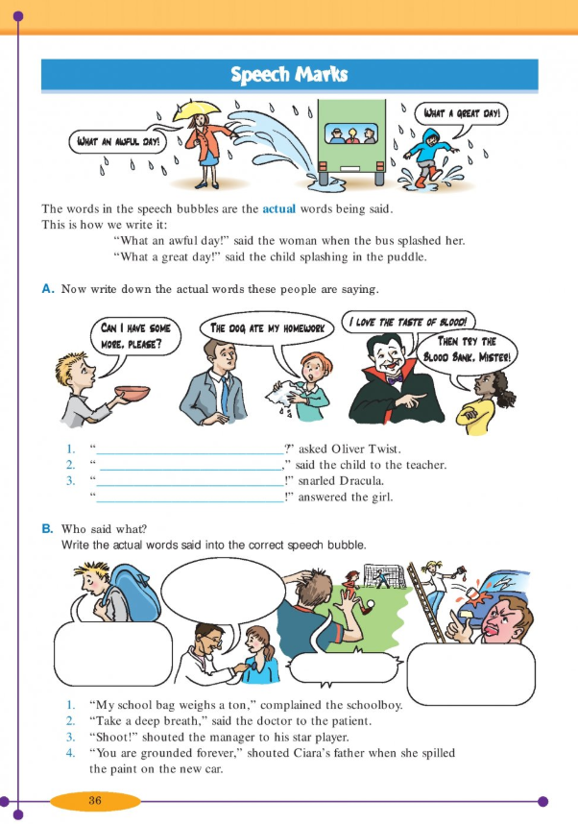

Poem, ‘Planet Roll Call’.
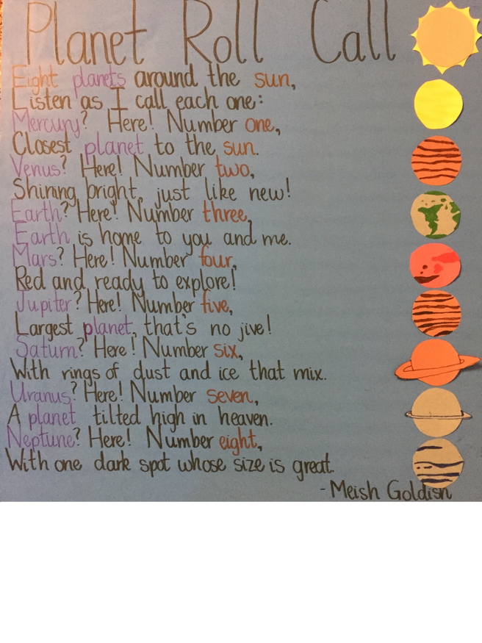

Planets in order
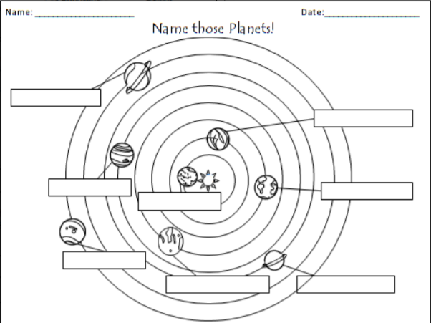

Scéal Cú Chulainn
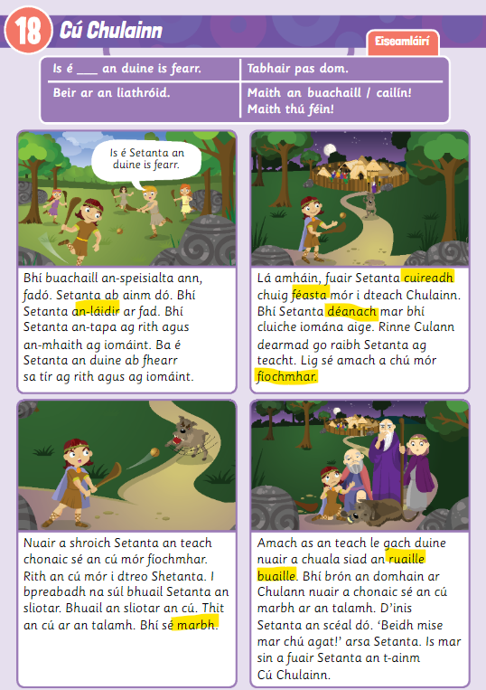

Ceisteanna Cú Chulainn
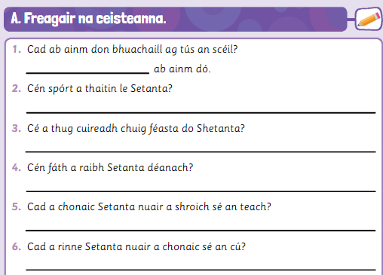

Aí sounds
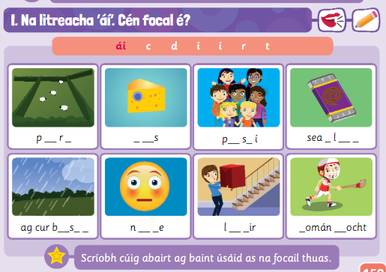

Brain Teasers 27&28
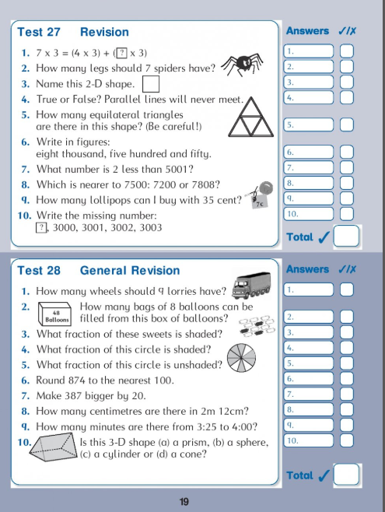

Brain Teasers 29&30
