Ms. Cawley - English:
Hello everyone, I hope you are all well. As you all know school won’t be back before the summer. I know this is a very strange time for us all. Keep trying to get a little bit of work done and read as much as you can. Stay safe
Monday:
Here is another tongue twister for this week. Practice it slowly and then see how quick you can get. Maybe you could challenge someone in your house to see who can say it the best or the quickest?
http://learnenglishkids.britishcouncil.org/tongue-twisters/cup-coffee

Comprehension – Eiffel Tower. Click on the pdf and read the comprehension and answer the questions. Follow question 10 to learn how to draw the Eiffel Tower

Tuesday:
Tongue twister time! Who do you think is best at saying it in your house?
Revise opposites by play this game.
https://www.eslgamesplus.com/practice-adjectives-opposites-esl-connector-matching-game/
Which word has the closest meaning to the underlined word? You could use a dictionary to help you if you find this a bit tricky.
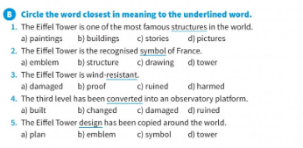
Wednesday:
Keep going with the tongue twister, if you had access to a mobile phone you could record yourself saying it.
Try these crosswords: http://iteslj.org/cw/3/ck-dolch09.html and http://iteslj.org/cw/3/ck-dolch10.html click on the numbers to see the clues. Complete the crossword puzzle, then click on "Check Puzzle."

Thursday:
I thought today you could try something different! Watch the following video on how to make a bowling game. You might need a couple of days to collect all the materials but I think it would be great fun! You could challenge a family member!
http://learnenglishkids.britishcouncil.org/how-videos/how-make-bowling-game

Friday:
This game revises actions and nouns. Click on the dice and answer the questions to reach home.
https://www.eslgamesplus.com/action-verbs-noun-collocations-esl-vocabulary-grammar-interactive-crocodile-board-game

