Monday | Tuesday | Wednesday | Thursday |  | Friday
Brain Teaser 23 | Brain Teaser 24 | Brain Teaser 25 |  | Brain Teaser 26 | Friday Length Recap
 |  | Fractions | Decimals
Length-  Remember 100cm = 1 metre | 1m = 100cm  0.1m= 10cm  0.01m= 1cm | Remember to find a fraction of a number:  Divide by the bottom,  multiply by the top | units decimal point tenths hundredths thousandths  4 . 2 5 7  4 . 2 5 7 1000  10 100  4.257km= 4,257 metres
15 mins written work per day
Mathemagic pg 75 into your copy | MM pg 76 | MM pg 81 | MM pg 82 |  | Perimeter Worksheet- Roger Robot
Extra activities | Estimate the length of the perimeter of your bedroom/ the kitchen/ the front door and any other bigger spaces you would like to measure. If you have a measuring tape, use it to measure each side and then add up to find the length of the perimeter.  If you don’t have a measuring tape, cut string to measure a metre (use your ruler to measure out 100cm) that can be used to measure bigger areas.
Ms. Murtagh and Mrs. Harte’s Maths Class - May 18th – 22nd

Roger Robot
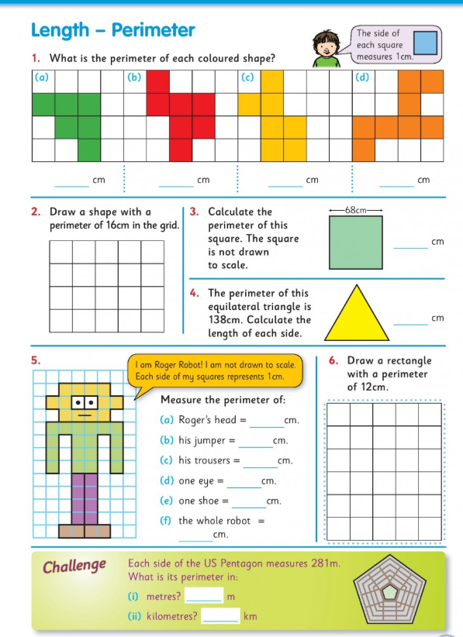

Monday & Tuesday Mental Maths
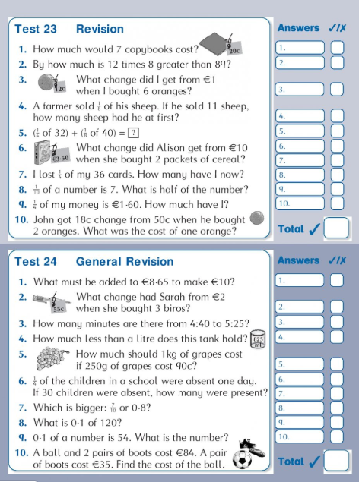

Wed and Thursday
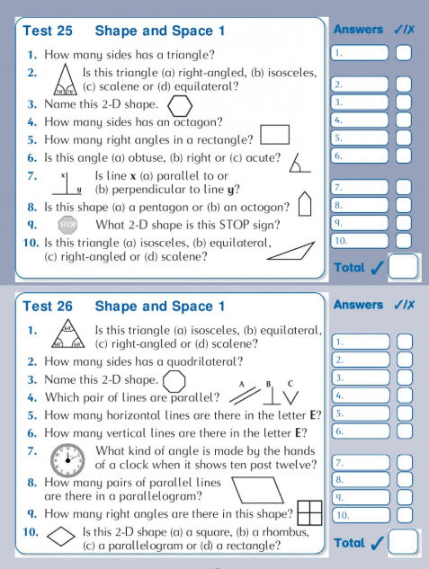

Friday Length Recap
