English: Tuesday and Wednesday – Poem: The Months
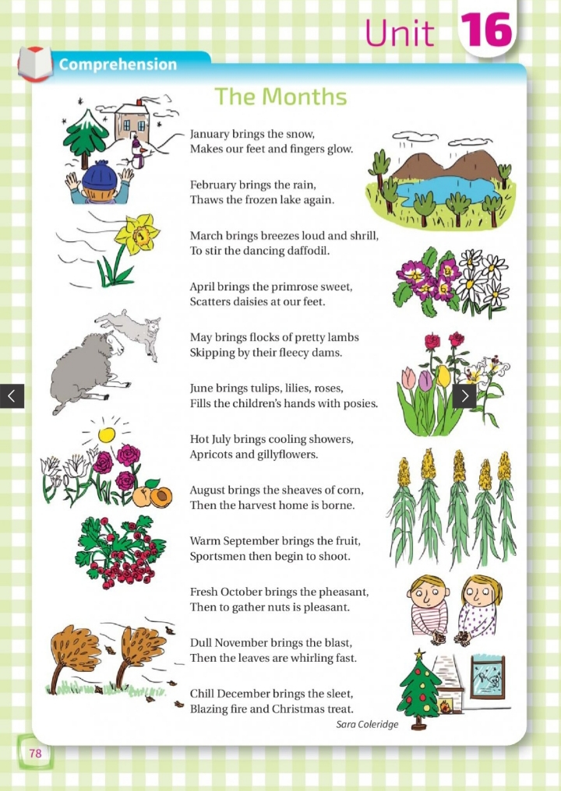
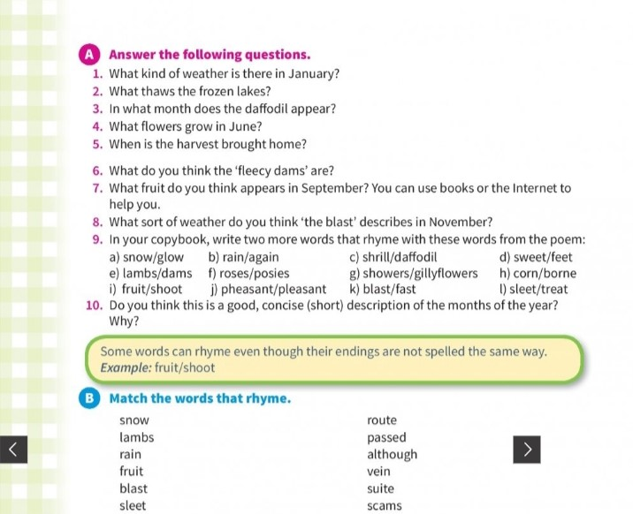
English: Acrostic poem example and template – Thursday
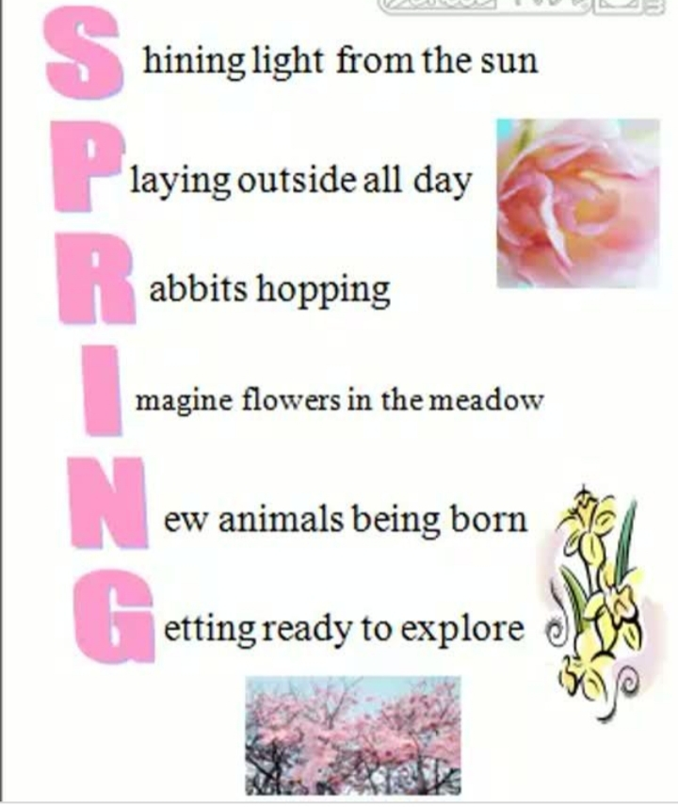
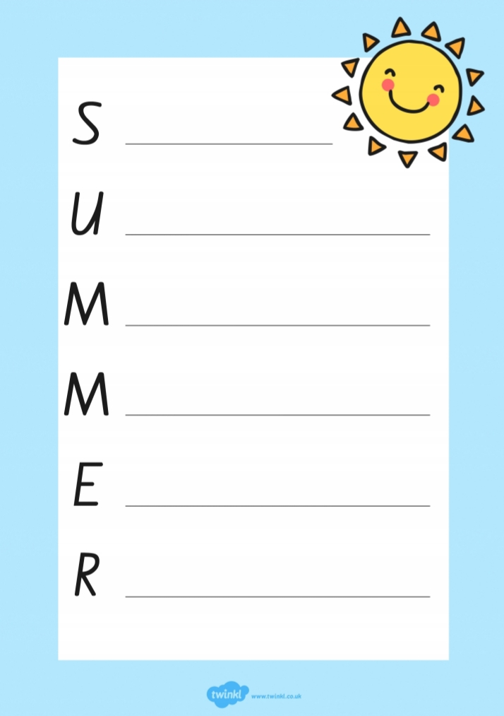
Gaeilge: Cloisim le mo Chluasa (Tuesday, Wednesday and Thursday)
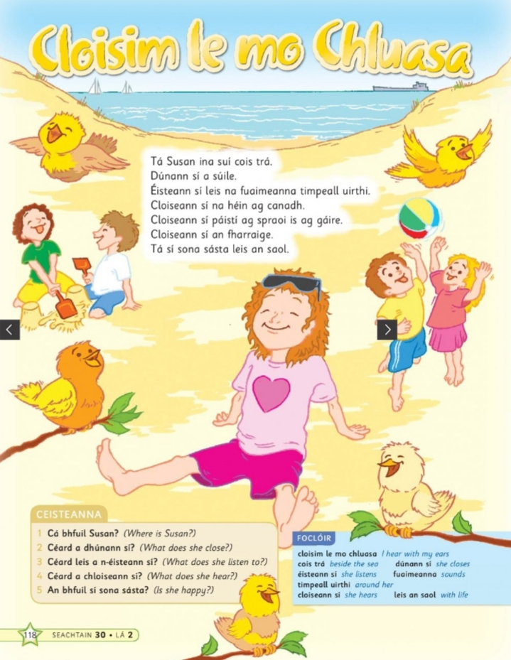
Gaeilge: Thursday
Cloisim le mo Chluasa – I Hear with my Ears
Fíor nó Bréagach – True or False
Léigh na habairtí agus roghnaigh fíor nó bréagach (Read the sentences and choose true or false)

- Tá Liam ina shuí cois trá. ________

- Dúnann Susan a suile. ________

- Cloiseann Susan páistí ag spraoi agus ag gaire. ___

- Cloiseann Susan ceol. ________

- Tá Susan sona sásta leis an saol. _______

Music – The Beach Boys (Monday)

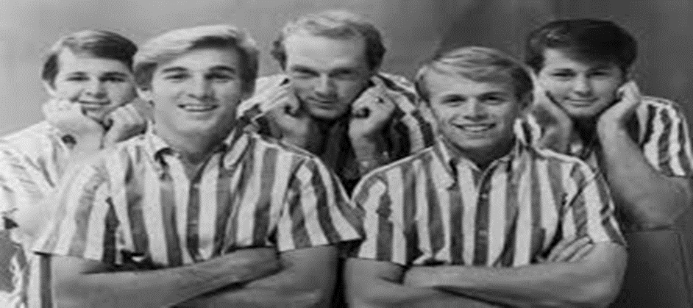

- The Beach Boys were formed in California in 1961.

- The five original members were the three brothers Brian, Carl and Dennis Wilson, their cousin Mike Love and their friend Al Jardine.

- The Beach Boys music was categorised as pop/rock or surf pop.

- Their music was recognisable for it close vocal harmonies and it’s upbeat and positive style.

- Their music was a big influence on The Beatles and lots of other bands.

- Two of their most famous songs are 1) Surfin’ USA and 2) Wouldn’t It Be Nice.

SESE – Thursday (Scavenger hunt)
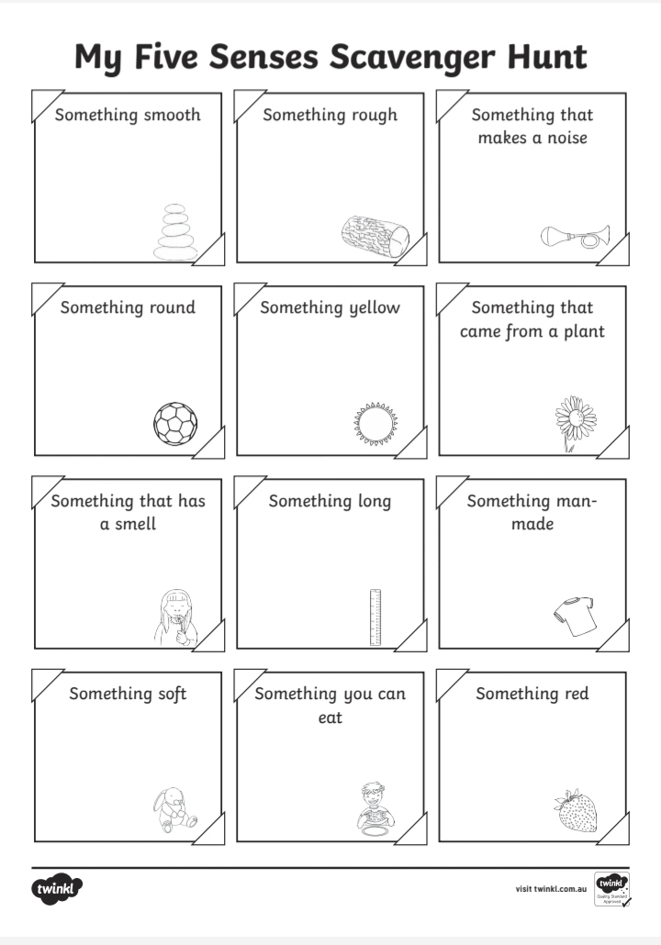

SESE/Art – Invent and draw a new flower (Friday)

