Tuesday: Worksheet 1
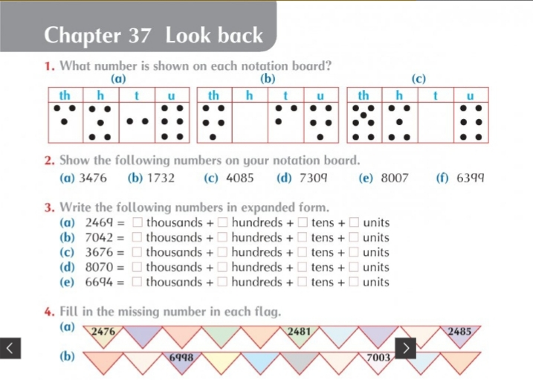
Wednesday: Worksheet 2
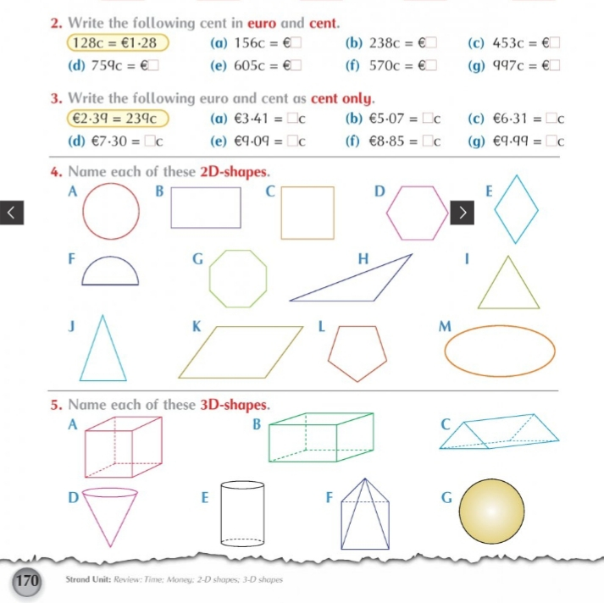
Thursday and Friday: Worksheet 3
