Tuesday and Wednesday: Brain teasers – tests 25 and 26
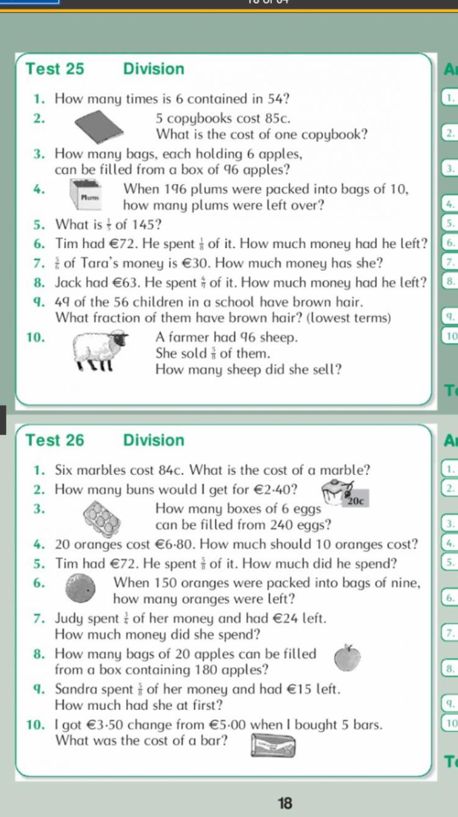
Thursday: Brainteaser – test 27
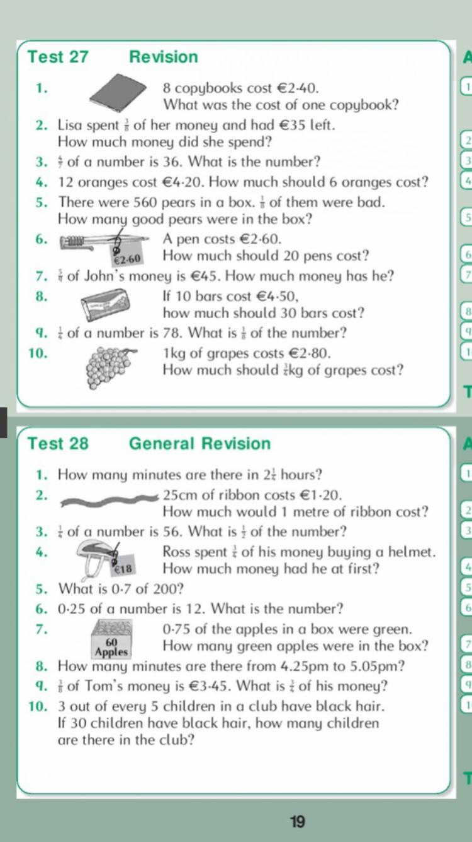

Tuesday and Wednesday – Worksheet 1: Time
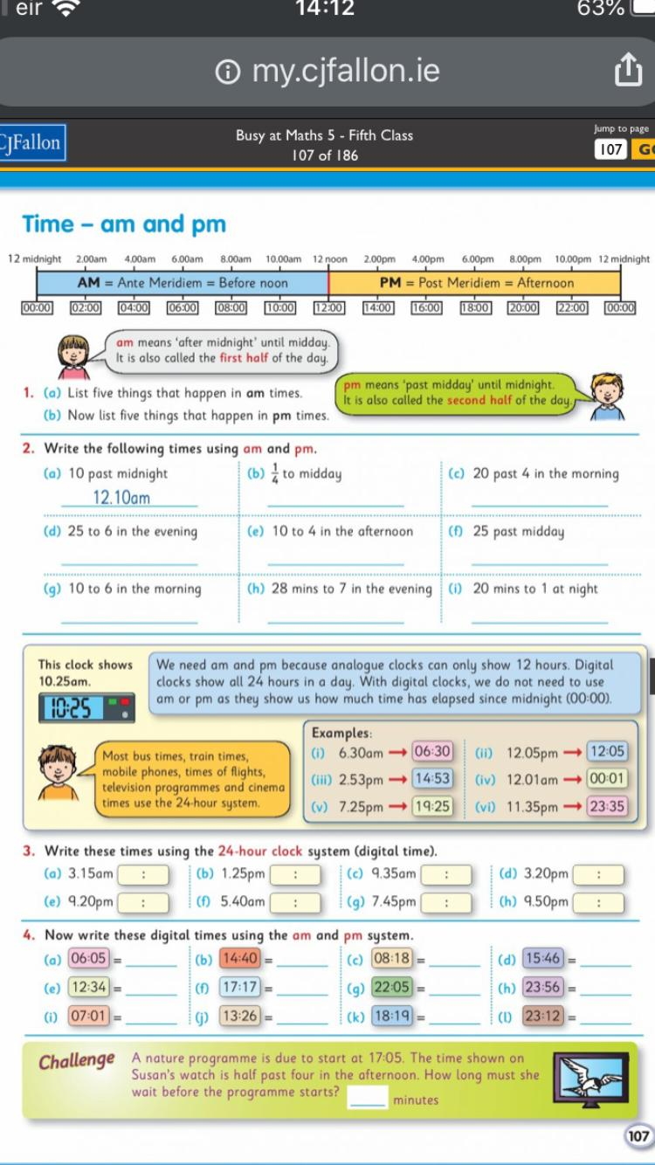
Thursday and Friday – Worksheet 2: TV Guide (time)
