Monday | Tuesday | Wednesday | Thursday | Friday
English:  We know that lots of you have been reading many interesting books over the past few weeks – please take a photo of the book you are reading at the moment and send it to Seesaw.  Please write a little paragraph about the book and whether you would recommend it to others.  Mental Maths tables:  All classes  Tables 2/4/6 revision  Daily Ten: https://www.topmarks.co.uk/maths-games/daily10  https://www.topmarks.co.uk/maths-games/hit-the-button  Mr Donohues class:  https://www.math-drills.com/multiplication/multiplication_facts_to_81_zeros_001.pdf?v=1414199978  Ms Kenna’s class:  Number of the day = 672  Decimals Revision: Ordering Decimals sheet 1(see below)  *The answers are included at the end for you to correct your work when you are finished.  Mrs Harte and Ms Murtaghs class:  Brainteasers 35 and 36 (see below) | English:  Would you rather questions?  Have some fun and read, discuss and answer the would you rather questions with your family!  See questions below  Mental Maths Tables:  All classes  Tables 7/8 revision  Daily Ten: https://www.topmarks.co.uk/maths-games/daily10  https://www.topmarks.co.uk/maths-games/hit-the-button  Mr Donohues class  https://www.math-drills.com/addition/addition_3digit_3digit_001.pdf?v=1480472957  Ms Kenna’s class:  Number of the day = 1671  Decimals Revision: Ordering Decimals sheet 2(see below)  *The answers are included at the end for you to correct your work when you are finished.  Mrs Harte and Ms Murtaghs class:  Brainteasers 37 and 38(see below) | Unfortunately our school tour was not to be this year. Today we are hoping that you will go on a virtual school tour instead.  We would like you all to pay a virtual visit to San Diego Zoo  This is one of the most famous zoos in the world.  Please have a look at some of the animals that live at San Diego Zoo.  https://kids.sandiegozoo.org/videos  Read some stories about the wonderful animals that live there  https://kids.sandiegozoo.org/stories  Have a look at the games section also: https://kids.sandiegozoo.org/games | English:  Please return to the San Diego Zoo website and choose your favourite animal that you saw on the virtual tour yesterday.  Please write ten sentences about this animal and upload this to Seesaw (include a picture of the animal if you would like)  https://kids.sandiegozoo.org/animals  Check out https://www.artforkidshub.com/how-to-draw/animals/  for inspiration and guidance on how to draw animals.  Gaeilge: https://www.duolingo.com/course/ga/en/Learn-Irish  Mental Maths Tables:  All classes 7/8 tables  Write out tables and practice them  Mr Donohues class:  https://www.math-drills.com/subtraction/subtraction_multidigit_0303_001.pdf?v=1479782785  Ms Kenna’s class:  Number of the day = 103  Decimals Revision: Rounding Decimals sheet(see below)  Mrs Harte and Ms Murtaghs class:  Brainteasers 39 and 40 (see below) | Today is Fun Friday!!  We are assigning no specific work today but we would love you to do something fun with your family.  As always we love to hear that you have been outside at some stage- go for a walk, have a game of football or go for a cycle.  Some children have been baking a lot during the past few weeks – please send on some photos of what you have been baking to Seesaw- we would love to see what you have been baking.  Here is a link to some easy butterfly buns if you would like to try them: https://www.odlums.ie/recipes/butterfly-buns/  Here is a link to some simple three ingredient scones:  https://www.odlums.ie/recipes/3-ingredient-scones/  We would love to see your efforts if you do try them!
Physical Exercise: 60 minutes make sure to get active every day – go for a walk, cycle your bike, practice your GAA or Soccer drills,
Go Noodle, Cosmic kids, Yoga, Kids Pilates
We also encourage our children to take part in The Body Coach Joe Wicks daily P.E session on Youtube at 9am
DEAR Time: Spend 15 minutes reading your book.
Extra activity: If you get a chance please watch RTE2 daily school at eleven o’clock each morning also!

Stay well and safe – we are thinking of you all and miss you all!

Would you rather questions!

1.Would you rather have a magic carpet that flies or your own personal robot?
2.Would you rather be the worst player on a team that always wins or the best player on a team that always loses?
3.Would you rather be able to control the weather or have the ability to talk to animals?
4.Would you rather see a fireworks display or go to a concert?
5. Would you rather go water skiing or snow skiing?
6. Would you rather eat doughnuts or sweets?
7. Would you rather be ten years older or four years younger?
8. Would you rather fly a kite or ride on a scooter?
9. Would you rather only be able to crawl on all fours or only be able to walk backwards?
10.Would you rather be a famous actor or a famous singer?
11.Would you rather be able to fly or be invisible?
12. Would you rather never have to shower again or never have to clip your toenails again?
13. Would you rather have the chance to design a new toy or the chance to direct a movie?
14. Would you rather be the funniest person alive or the smartest person alive?

Mrs Harte and Ms Murtaghs maths class Monday
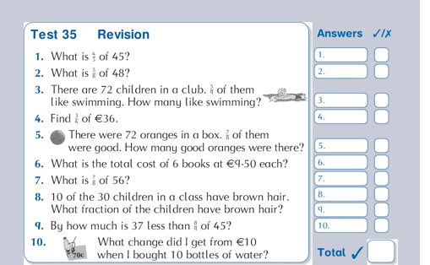

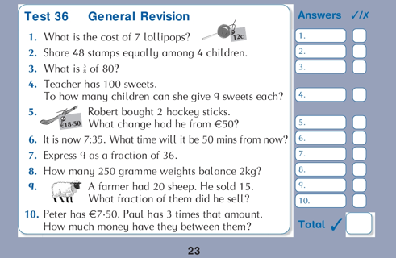
Mrs Harte and Ms Murtagh Tuesday
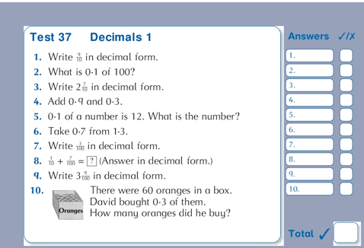
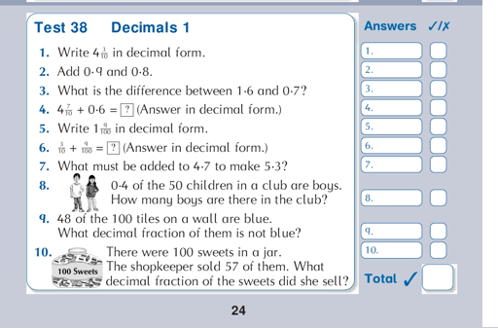
Mrs Harte and Ms Murtaghs class Thursday:
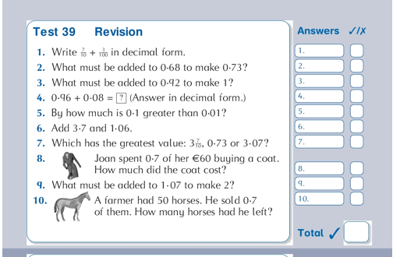
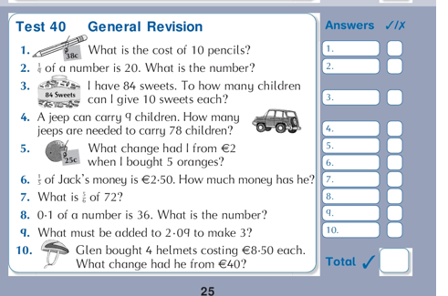
maths class M